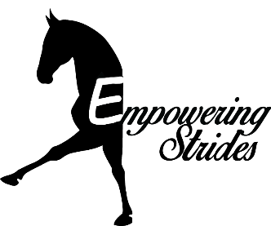
‘FUN’draiser Horse Show
Saturday June 25th, 2022

Location: 15205 NE 172nd St. Woodinville, WA 98072
Office Opens at 8:00 am
Website: www.EmpoweringStrides.com

Classes Start at 9:00 am

Arena One
- Leadline Walk Only Don’t Spill
- Leadline W/T Don’t Spill
- Walk Only Don’t Spill
- Walk/Trot Don’t Spill
- Leadline WO Egg/Spoon
- Leadline Walk/Trot Egg/Spoon
- Walk Only Egg & Spoon
- Walk/Trot Egg & Spoon
- Leadline WO Ride-A-Buck
- Leadline W/T Ride-A-Buck
- Walk Only Ride-A-Buck
- Walk/Trot Ride-A-Buck
- Leadline WO Equitation
- Leadline W/T Equitation
- Walk Only Equitation
- Walk/Trot Equitation
- Leadline WO Ground Pole Eq
- Leadline W/T Ground Pole Eq
- Walk Only Ground Pole Eq
- Walk/Trot Ground Pole Eq
Show Rules
- All ages show, divisions are open to everyone.
- Schooling attire and tack accepted. Tack does not need to be discipline specific.
- This show is not rated and/or recognized. Judges are not rated and/or recognized.
- Ribbons will be offered to 6th Place.

Class Descriptions
- Ride-A-Buck: Rider puts ‘dollar bill’ between calf and horse/saddle. Riders are excused from the class when they lose the dollar, last one standing wins.
- Don’t Spill: Rider’s hold a glass of water while riding a flat class, can include halting, circling, backing and speed of class. Class is placed based on how much water is left in the cup.
- Egg and Spoon: Rider’s hold a spoon balancing an egg and ride a flat class. Riders are excused when they drop their egg, last one standing wins.
- Barrels/Flags/Poles: Will be timed. Penalties for knocking/dropping an obstacle, breaking gate (trotting in a walk/only) and going off course.
- Obstacle course and ground poles will be judged based on rider, handling and pattern.

Arena Two
- Leadline WO Barrels
- Leadline W/T Barrels
- Walk Only Barrels
- Walk/Trot Barrels
- Leadline WO Poles
- Leadline W/T Poles
- Walk Only Poles
- Walk/Trot Poles
- Leadline WO Flags
- Leadline W/T Flags
- Walk Only Flags
- Walk/Trot Flags
- Leadline WO Obstacle Course
- Leadline W/T Obstacle Course
- Walk Only Obstacle Course
- Walk/Trot Obstacle Course

