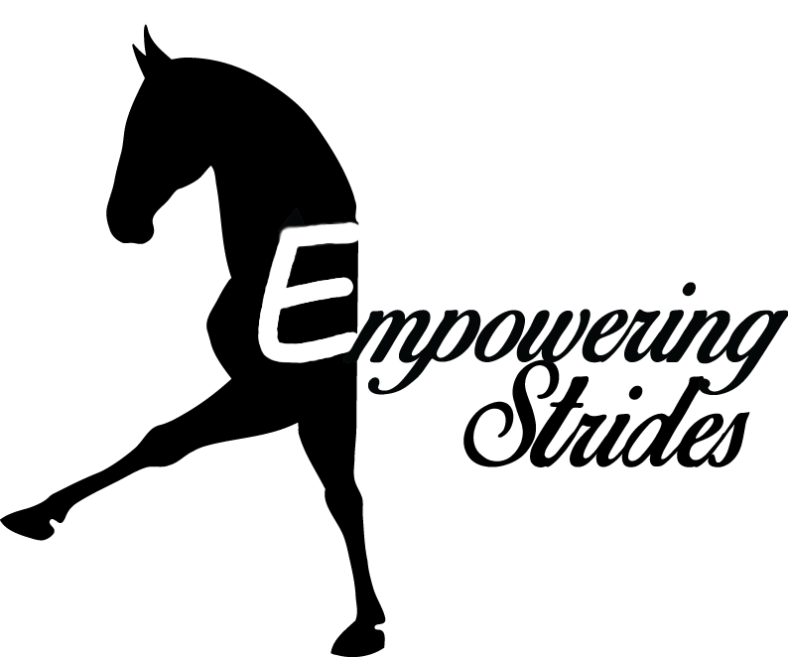
‘Fun’draiser Horse Show  When  Saturday, June 25th, 2022  Where  Hollywood Hill Saddle Club  15205 Northeast 172nd Street, Woodinville, WA 98072  What  An unrated show for all ages to have fun. The purpose of this show is to offer a fun show option to rider’s who may not have chances elsewhere. We have a full set of classes for two leadline divisions, which no other local show has.  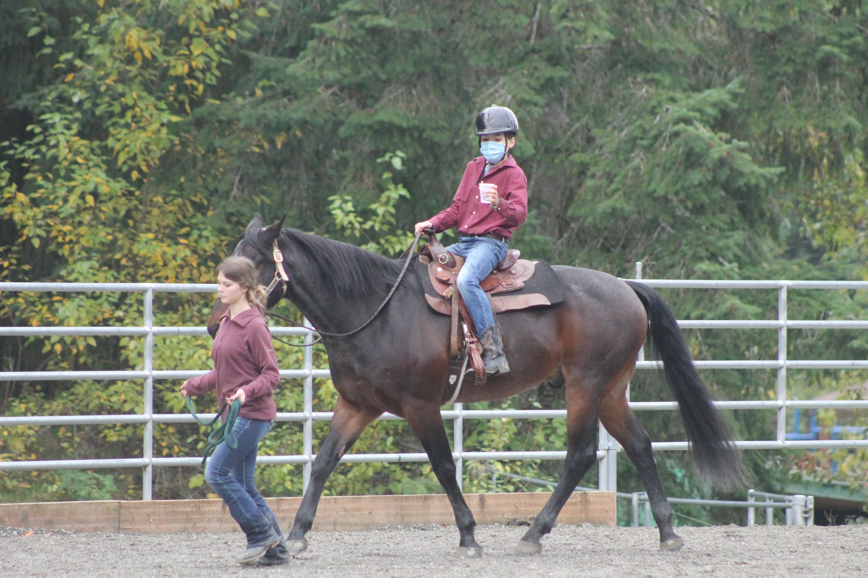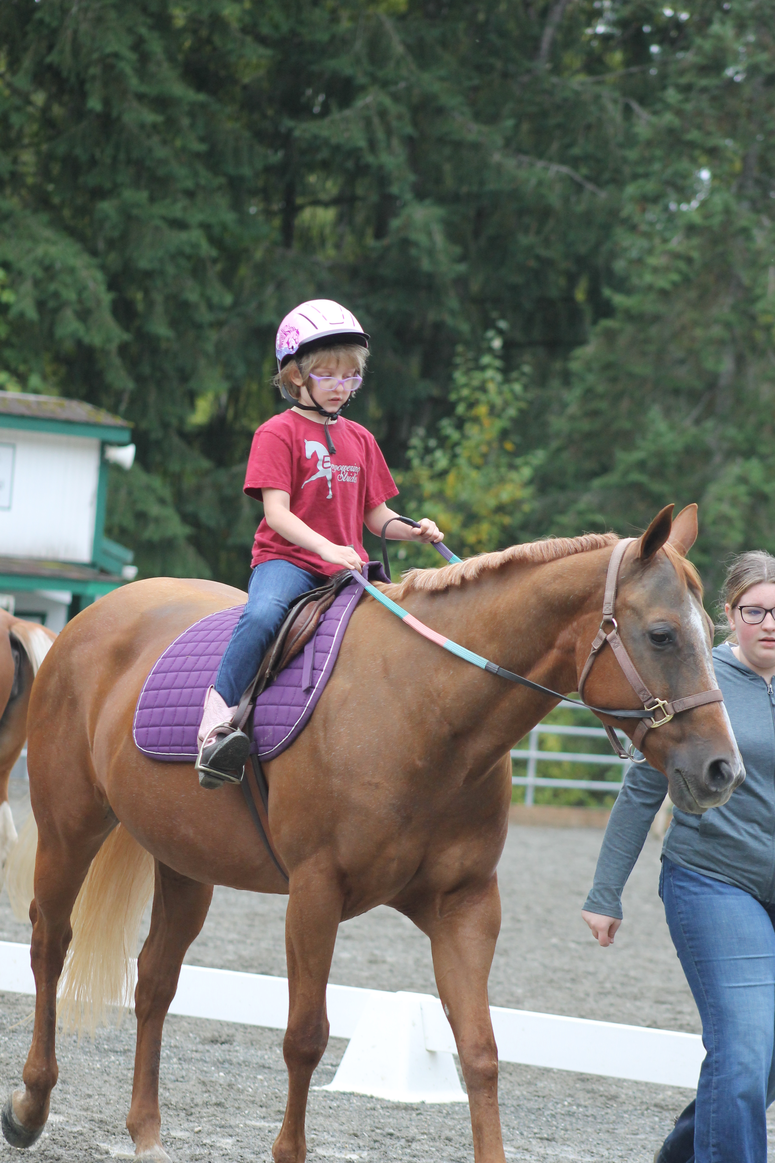 | Classes  Equitation Class  Ground Pole Equitation  Barrels  Poles  Flags  Ride-A-Buck  Egg and Spoon Race  Don’t Spill-Cup Class  Obstacle Course  *$10 per class!  Divisions  Leadline- Walk Only  Leadline- Walk/Trot  Walk Only  Walk/Trot  *All Ages  *Ribbons to 6th Place  Benefiting  The care and wellness of the Empowering Strides horses.  501c3 Tax ID 47-5182998  Sponors  If your business is interested in sponsoring a division, please email:  EmpoweringStrides@gmail.com

